CURRICULUM VITAE

Name | SAMEER CHAUDHARY | 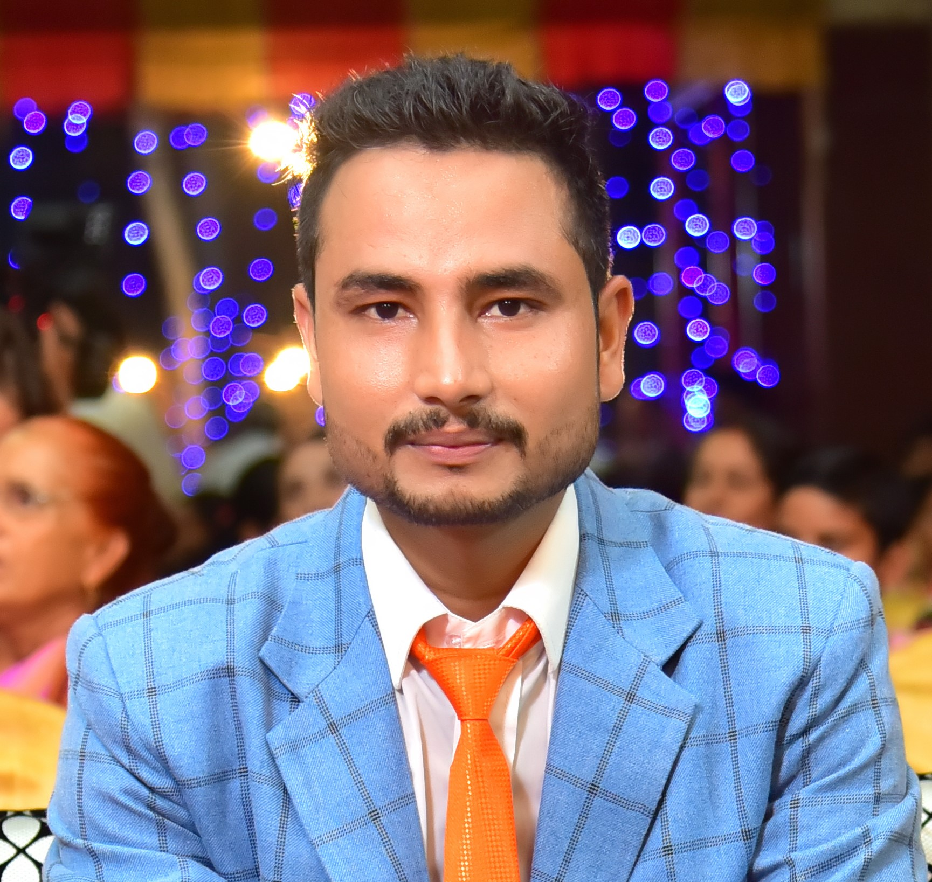
Date of Birth | AUG 1ST 1992
Contact Address | T+PO.-Banat, Home No.-126, Prem Nagar 2, Dist.- Shamli, UP-247776
Phone | +91-9997123043,+91-7027962430
Email | beniwal147@gmail.com

Education

M. Sc. (Organic Chemistry)  HNBGU, Garhwal, Shrinagar, UK. | 2014
B.Sc. (CBZ)  CCSU, Meerut, UP. | 2012
12th Bio-Science  Govt. VV Inter College, Shamli. UP. | 2009
10 th  Govt. Vadic Inter College, Sisualli (MZN), UP. | 2007

WORKING EXPERIENCE

- 3 Year’s Experience in quality control Deptt. As chemist in CPF INDIA PVT.LTD.

KEY SKILLS

- Depth knowledge of Quality Control & Quality Assurance.
- Physical & chemical analysis of all the raw materials & supplements used in the manufacturing process of cattle & poultry feed.
- Execution of formulation in Production & quality control in manufacturing process.
- Performing Lab analysis & maintaining all the records using SAP for purchasing materials.

Credit seminar

- Credit seminar on “” during M.Sc.

COMPUTER PROFICIENCY

- Basic knowledge of computer including internet, excel, word, power point etc.

HANDS ON EXPERIENCE till date

Company | CPF India Pvt. Ltd. | FEB/2015 to till
Designation | Q.C.-CHEMIST
Responsibilities | - Set up of analytical laboratory.  - Handling overall activities of quality control related to raw materials, finished goods.  - Physical & chemical analysis of raw materials, finished goods.  - In process quality control of production process.  - Handling the market complained & taking corrective action.  - To maintain all laboratory records.  - Reporting directly to higher management.

PERSONAL SKILLS

- Willingness to learn and ready to face new opportunities with full energy.
- Good communication skill

PERSONAL DETAILS

Father name Mr. Liyakat Ali
D.O.B. 01.08.1992
Birth Place Shamli
Sex Male
Marital status Single/ Unmarried
Linguistic Proficiency English, Hindi, Punjabi
Strength Inquisitiveness & Self Confidence
Current CTC 2.7 L /Y
Expected Negotiable

INSPIRING LINE OF LIFE

"Any situation is as good as we make it"

Date :

Place : Kailash Chand

